Homework projects
Social influence
http://www.iwm.org.uk/exhibitions/iwm-london/the-holocaust-exhibition | The Holocaust Exhibition (Obedience)  The informative Holocaust exhibition at the Imperial War Museum uses historical material to tell the story of the Nazi persecution of the Jews and other groups before and during World War II.
http://www.bbc.co.uk/programmes/p00f8mzr | Write down 3 things you have learnt about Solomon Asch? Why was his research so important?
http://www.ted.com/talks/philip_zimbardo_on_the_psychology_of_evil | The psychology of evil. Zimbardo. What does Zimbardo suggest evil is caused by?
http://documentaryheaven.com/the-power-of-the-situation/ | Milgram’s experiment. Write down 3 things about Milgrams experiment.  Could you summarise 3 key findings from this documentary?
https://www.youtube.com/watch?v=4b7YFtiE5EA | Derren Brown replicating the Milgram experiment.  What did he find?  Were they the same as the original experiment?
http://www.jewishmuseum.org.uk/ | The Jewish museum (social psychology)  Visit the Jewish museum and think about why people obey?
http://www.bbc.co.uk/programmes/b01gf5sr | Jules Rotter and Locus of control. What does this clip suggest about people with internal locus of control?  What does it say about people with an external locus of control?
http://www.bbc.co.uk/programmes/b008crhv | Zimbardo and the Stanford prison experiment. Write down 4 new things you learnt from this clip?
Watch the film: ‘The experiment.’ | How does the film differ from the original Stanford experiment?  Do you think this was an accurate portrayal?
https://www.wlc.edu/uploadedFiles/success/SurveyLocus.pdf | What type of locus of control do you have?  How does this affect stress levels? Are you more at risk of stress?
http://topdocumentaryfilms.com/we-have-ways-of-making-you-talk/ | Documentary on torture and how to get information out of prisoners.
http://www.bbc.co.uk/programmes/b00b529r | Audio clip: Kitty Genovese. (Bystander effect)  Why do some people do nothing when people need help?
http://topdocumentaryfilms.com/ghosts-of-abu-ghraib/ | ‘The ghosts of Abu Ghraib’- Following the atrocities of the Iraq prison, a reflection of how the power of the situation can make good people do bad things.

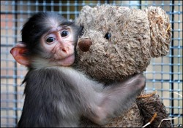
Attachment
http://www.bjdd.org/new/105/81to95.pdf | Malekpour. ‘Effects of attachment on early and later development.’ (2007)  Summarise the information into Aims, procedure, findings and conclusions.
https://www.youtube.com/watch?v=hmdycJQi4QA | Genie documentary. Write down 3 bullet points about the effect of privation on Genie.
Research a developmental psychologist.  - Bowlby  - Lorenz  - Ainsworth  - Harlow | Create a social media page about the psychologist of your choice.
http://www.bbc.co.uk/programmes/b04581j9 | Sir Micheal Rutter on challenging Bowlby’s theory.  Create 3 evaluative points on Bowlby’s theory.
http://nobelprize.org/educational_games/medicine/pavlov/ | Pavlov online game. Can you make the dog salivate using only the bell?
http://www.daycaretrust.org.uk/ | Find out 3 things you didn’t know about day care.
http://www.bbc.co.uk/programmes/b00ly7lp | Write down 4 things about Harlow’s Monkey experiments that you didn’t know before.
http://www.bbc.co.uk/programmes/p00f8n6q | List to the clip on Mary Ainsworth. Write down 3 new things you learnt about Mary Ainsworth.
http://www.bbc.co.uk/programmes/b01pzr00 | Do you think children under 2 should watch TV?  Why not create your own podcast about a study?
http://www.ted.com/talks/frans_de_waal_do_animals_have_morals | Watch the following talk on moral behaviour in animals
http://www.ted.com/talks/georgette_mulheir_the_tragedy_of_orphanages | What does this suggest about children in institutional care?
http://www.bbc.co.uk/programmes/b00b7lrb | Wild boy of Averyon- Is attachment innate? What happens to us when we don’t have other humans to attach to?

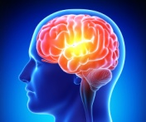
Memory
http://faculty.washington.edu/eloftus/ | The home page for Elizabeth Loftus. There are links to various articles about EWT.  Read an article about EWT and create an aims, procedure, results and conclusion for the study.
http://www.kent.ac.uk/psychology/department/people/hollidayr/cognitive2003.pdf | Robin Holliday: ‘The Effect of a Prior Cognitive Interview on Children’s Acceptance of Misinformation’  Read the following research.  What does it suggest about age and EWT?
http://human-factors.arc.nasa.gov/cognition/tutorials/ModelOf/memory1.html | Three memory experiments attached. Try one out for yourself on your family and friends.
http://www.bbc.co.uk/programmes/b00yhv36 | Write down 3 things you learnt about Loftus and EWT from the audio clip.
http://www.bbc.co.uk/programmes/b00t6zqv | Do you think HM’s case study is ethical?  What does the case study suggest about memory?  Why can’t we replicate the study?
http://www.ted.com/talks/daniel_kahneman_the_riddle_of_experience_vs_memory | Watch the following clip. What does it suggest about the relationship between experience and memory?
http://www.bbc.co.uk/programmes/p00f8n47 | Listen to Sir Frederick Barlett and his famous study called ‘war of the ghosts’. What does it suggest about memory?
http://www.bbc.co.uk/programmes/b015zm90 | Cognitive psychologist Steven Pinker talks about the importance of memory.  Write down 4 key points.
http://www.ted.com/talks/elizabeth_loftus_the_fiction_of_memory | Loftus on the fiction of memory. Watch the clip. What does Loftus suggest about memory?  Why can’t it be trusted?
http://www.ted.com/talks/scott_fraser_the_problem_with_eyewitness_testimony | Fraser on the problems with EWT. Write down 5 things that make EWT unreliable?
http://www.ted.com/talks/joshua_foer_feats_of_memory_anyone_can_do | Foer on memory strategies.  Try out one of these memory strategies yourself.
http://whoville.ucsd.edu/PDFs/260_RempelClower_etal_JNeurosci1996.pdf | Case studies of memory loss.  What does it suggest about the importance of the hippocampus?
http://www.bbc.co.uk/programmes/b01j5j24 - | Claudia Hammond- Alzheimers disease radio clip
Why not watch a film on memory loss:  - Finding nemo  - Machinist  - Shutter island  - The Vow/ The Notebook  - Bourne identity  - 50 first dates  - Memento | Write about what types of memory loss are in each film. What has caused the memory loss?:  - What type of memory loss does Dory suffer from?  - What causes Christian Bales memory loss? Is it the only thing he suffers from?  - In Shutter Island is memory loss the only thing that he suffers from?

Psychopathology
http://www.telegraph.co.uk/news/worldnews/northamerica/usa/8296954/How-One-Flew-Over-the-Cuckoos-Nest-changed-psychiatry.html | Watch one flew over the cuckoos nest. What does it suggest about mental illness?  Do you think it was an accurate portrayal?
Watch one of the following films:  - Vertigo (Phobias)  - A beautiful mind (Schizophrenia)  - Memento (memory loss)  - The Aviator (OCD)  - Rain Man (Autism) | Write 3 key points about the mental disorder?  What are the symptoms?  How did they suffer?  Why do they have the disorder in the first place?
http://documentaryheaven.com/institutionalized-mental-health-behind-bars/ | Mental health care system in USA? Does it really work?
http://www.bbc.co.uk/programmes/b01g5yy1 | Wolpe and Systematic desensitisation.  How does systematic desensitisation treat patients? Who does it help and how?
http://www.bbc.co.uk/programmes/b00lny48 | David Rosenhan and the Pseudo patient. Why was this research so revolutionary?
http://www.bbc.co.uk/programmes/p00f8n5n | What does Little Albert (Watson and Rayner) suggest about the way we learn fear?
Research a mental disorder:  - OCD  - Schizophrenia  - Depression  - Anxiety disorder  - Bipolar | What are the symptoms?  How is it caused?  How can we treat it?  (NHS website is a good place to start)
http://www.dailymail.co.uk/health/article-2449864/Artist-Toby-Allen-imagines-mental-illness-monsters.html | Read the following article.  Can you make your own monster for a mental illness?
http://documentaryheaven.com/institutionalized-mental-health-behind-bars/ | Institutionalized: Mental Health Behind Bars
http://documentaryheaven.com/psychopath-next-door/ | How can we deal with individuals who are classed as psychopaths?
http://documentaryheaven.com/louis-theroux-by-reason-of-insanity/ | Louis Theroux explores Schizophrenia and other mental disorders within an instutionalised setting
http://www.bbc.co.uk/programmes/b017w65r | Uta Frith on Brain disorders (E.g; Autism)
http://www.ted.com/talks/laurel_braitman_depressed_dogs_cats_with_ocd_what_animal_madness_means_for_us_humans | Laurel Braitman: Can dogs experience OCD or depression?
http://www.ted.com/talks/oliver_sacks_what_hallucination_reveals_about_our_minds | Oliver Sacks on hallucinations.
http://nymag.com/scienceofus/2015/08/7-of-oliver-sacks-most-fascinating-case-studies.html  http://topdocumentaryfilms.com/phantoms-in-the-brain/ | If you like this try reading about Oliver Sacks case studies:  - The man who mistook his wife for a hat.  - The conductor who lost all his memories, but could still remember music and his wife.  - The family man who snubbed his wife and child, but loved strangers, after brain surgery.
http://topdocumentaryfilms.com/stephen-fry-the-secret-life-of-the-manic-depressive/ | Documentary- Stephen Fry on manic depression.
http://topdocumentaryfilms.com/multiple-personalities/ | Documentary on multiple personalityies.
http://topdocumentaryfilms.com/the-boy-with-the-incredible-brain/ | Documentary- A twenty-something with extraordinary mental abilities, Daniel is one of the world’s few savants. He can do calculations to 100 decimal places in his head, and learn a language in a week. (Autism)
http://topdocumentaryfilms.com/mystical-brain/ | Documentary on Mystical healing on treating depression

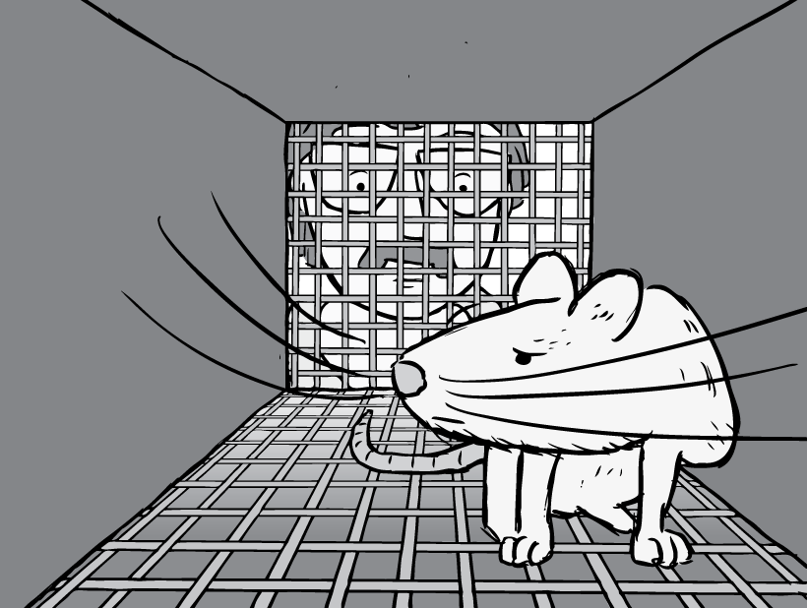
Research methods

http://www.youtube.com/watch?v=VFjaBh12C6s  https://www.youtube.com/watch?v=5fGu8hvdZ6s  https://www.youtube.com/watch?v=pGfwj4GrUlA | Watch these BPS videos on statistics. Write down some definitions of the key words based on the dance.
http://nationalzoo.si.edu/animals/webcams/  http://sandiegozoo.org/videos/ | Make your own naturalistic observations.  How often does the animal feed?  How often does the animal sleep?  Are there any behaviours that are strange?  What kind of observation did you use? And why?
https://www.youtube.com/watch?v=uQAmdZvKf6M  http://topdocumentaryfilms.com/a-class-divided/ | Do you think Jane Elliots study was ethically sound?
http://www.bbc.co.uk/programmes/b00t97xf  http://documentaryheaven.com/dr-money-and-the-boy-with-no-penis/ | Dr Money and the boy with no penis.  What ethical issues can you see breached in this case study?
http://www.intuitor.com/statistics/T1T2Errors.html | Type 1 and Type 2 errors in the justice system.  What is the difference between type 1 and type 2 errors?
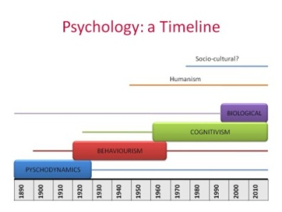
Approaches
http://documentaryheaven.com/dream-interpretation/ | Psychodynamic approach- Psychoanalysis uses a wide range of Projective testing including dream analysis.
http://www.ted.com/talks/carl_schoonover_how_to_look_inside_the_brain | Biological approach- Brain scanning techniques. Write down why you think brain scanning techniques are a scientific and reliable measure?
Freud Museum  http://www.freud.org.uk/ | Psychodynamic approach- The home of Sigmund Freud and his family until 1982, this museum helps students to understand Freud’s approach and aids exam knowledge.
http://topdocumentaryfilms.com/brain-secret-history/ | Biological approach- Documentary on the brain
http://www.bbc.co.uk/programmes/b00tjf56 Dora http://www.bbc.co.uk/programmes/b00bg335 Little Hans | Psychodynamic approach: Listen to one or both of these clips.  Both are case studies of Freud patients. What does this suggest about psychoanalysis?
http://www.ted.com/talks/steven_pinker_chalks_it_up_to_the_blank_slate | Behavioural approach- Tabula Rasa
http://www.bbc.co.uk/programmes/b01pzr00 | Behavioural approach- Should babies under 2 watch TV?
http://www.bbc.co.uk/programmes/b0639gxq | Behavioural approach- Skinner’s Pigeons
http://www.bbc.co.uk/programmes/b015zm90 | Steven Pinker on cognitive Psychology
http://www.ted.com/talks/martin_seligman_on_the_state_of_psychology | Humanistic Psychology- The power of Positive Psychology
http://www.bbc.co.uk/programmes/b063ztb0 | Humanistic approach- Carl Rogers and the person centred approach
http://www.bbc.co.uk/programmes/b01rw8mw | Humanistic approach- Maslow’s hierarchy of needs.

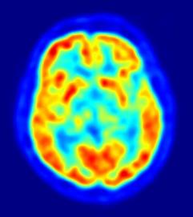
Biopsychology
http://www.bbc.co.uk/iplayer/episode/b06dsmn1/countdown-to-life-the-extraordinary-making-of-you-2-against-the-odds | BBC documentary: The making of you. In the Dominican republic a genetic abnormality that makes young girls become boys at puberty.
http://www.nobelprize.org/educational/medicine/split-brain/splitbrainexp.html | Split brain experiments game.
http://www.bbc.co.uk/programmes/b038c5qj | Russell Foster on Circadian rhythms
http://www.ted.com/talks/russell_foster_why_do_we_sleep | Russell Foster- why do we sleep.  What does Foster suggest about the function of sleep?
http://www.bbc.co.uk/programmes/b06j1qts | Plomin’s research on genetic intelligence.
http://www.bbc.co.uk/programmes/b05mrn29 | Audio clip of Sarah Jane Blakemore talking about the adolescent brain.
http://www.ted.com/talks/sarah_jayne_blakemore_the_mysterious_workings_of_the_adolescent_brain | Sarah Jane Blakemore explaining how the teenage brain changes on a neurological level
http://www.bbc.co.uk/programmes/b01mc11f | Richard Dawkins on human evolution
http://www.ted.com/talks/ariel_garten_know_thyself_with_a_brain_scanner | Ariel Garten on Brain scans and knowing yourself.
http://www.ted.com/talks/gero_miesenboeck | Gero Miesenboeck on fruit flies and mapping and changing neurons in the brain.
http://www.ted.com/talks/siddharthan_chandran_can_the_damaged_brain_repair_itself | Neural plasticity TED talk.
http://www.bbc.co.uk/programmes/b017w65r | Brain disorders (Dyslexia)
http://topdocumentaryfilms.com/the-secret-life-of-the-brain/ | Documentary on the secret life of the brain.
http://topdocumentaryfilms.com/alone/ | Documentary on sensory isolation using brain scanning techniques to show the effects of severe deprivation.
http://documentaryheaven.com/tourettes-swear-cant-help/ | Documentary on the neurological condition: Tourettes
http://topdocumentaryfilms.com/phantoms-in-the-brain/ | Phantoms in the brain- Looking at Alien hand syndrome, phantom limb and other neurological disorders.

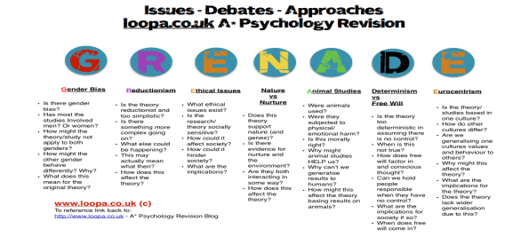
Issues, debates and approaches

http://articles.latimes.com/2012/jul/13/news/la-ol-blowback-pscyhology-science-20120713 | Is Psychology a science? Make a list of reasons why Psychology is not a science?
https://www.youtube.com/watch?v=kONM9WO5LGo | Nature Nurture debate. Which contributes most to behaviour?
https://www.youtube.com/watch?v=k1MFOuYiqAI | Do we have free will?
http://www.medicaldaily.com/nature-vs-nurture-debate-50-year-twin-study-proves-it-takes-two-determine-human-334686 | Nature vs Nurture article. Is this proof?
https://www.timeshighereducation.com/features/natures-defeat-of-nurture/104817.article | Nature beats Nurture?
http://www.simplypsychology.org/reductionism-holism.html | Reductionism or Holism?
http://www.bbc.co.uk/programmes/b00t97xf | Nature Vs nurture- The case of Joan/John (The boy with no penis)

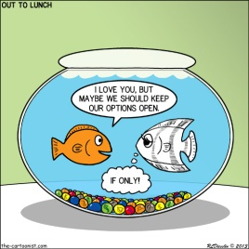
Relationships

http://www.pbs.org/wgbh/evolution/library/01/6/l_016_08.html | The sweaty t-shirt study and mate choice, complementary immune systems, etc.
http://www.flyfishingdevon.co.uk/salmon/year3/psy339evolutionarypsychology/evolutionarypsychology.htm | SALMON materials. Write down what it suggests about; parental investment, desirable partners, short and long term relationships.
http://www.flyfishingdevon.co.uk/salmon/year3/psy364sexual-selection/psy364sexualselection.htm | Write down 3 things about sexual attraction and human reproduction.
http://www.radford.edu/~jaspelme/_private/gradsoc_articles/individualism_collectivism/individualism_collectivism_1988.pdf | Paper about relationships in different cultures.  What does this suggest about collectivist and individualist cultures?  Write down 3 differences.
http://www.ted.com/talks/denis_dutton_a_darwinian_theory_of_beauty | Watch the following on an evolutionary approach to beauty. What does it suggest about relationships?
http://www.epjournal.net/wp-content/uploads/EP06575585.pdf | Read the article from David Buss. What does it suggest about sexual selection in humans?
http://www.ted.com/talks/helen_fisher_studies_the_brain_in_love | Watch the following video- What does it suggest about the brain when we are in ‘love’.  How can you apply this to the nature/nurture debate?
http://www.ted.com/talks/helen_fisher_tells_us_why_we_love_cheat | Helen Fisher on why we love and why we cheat?
TV series:  - Naked attraction (Explicit frontal nudity)  - Married at first sight | Consider the different explanations and theories of relationships.  Can evolutionary theory explain every type of attraction?

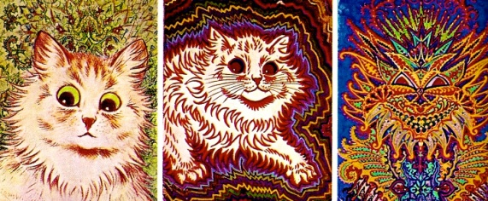
Schizophrenia
http://documentaryheaven.com/holding-sun/ | Holding the sun- Schizophrenia  Watch the following documentary  Write down 3 symptoms of Schizophrenia
http://www.bbc.co.uk/programmes/b01bwmvt | Robin Murray on why he’s changed his mind about the cause of Schizophrenia  Write down 3 key points from this audio clip.
http://www.ted.com/talks/eleanor_longden_the_voices_in_my_head | Eleanor Longden on her experience of Schizophrenia.
http://documentaryheaven.com/unbreakable-minds/ | Schizophrenia.  Write down 3 key points about Schizophrenia.
Watch one of the following films on Schizophrenia:  - Savage grace  - Soloist  - Donnie Darko  - Beautiful mind  - Sucker punch  - Mr.Brooks  - Proof  - Shine  - 12 monkeys  - Spider | What does the film suggest about Schizophrenia?  What are the symptoms?  Do you think the portrayal by the actor/actress is accurate?
http://www.youtube.com/watch?v=M3_hny4GFlY | What does Johnny suggest about Schizophrenia?  Does it affect how he functions? If so, How does it?
http://www.ted.com/talks/elyn_saks_seeing_mental_illness | Elyn Saks on how we perceive Schizophrenia.

Forensic Psychology

http://www.drinkanddrugs.net/ | A web portal for professionals in the substance misuse sector and wider health, social care and criminal justice settings, and for individuals affected by drugs and alcohol use.
http://documentaryheaven.com/an-interview-with-arthur-shawcross/ | -An interview with Arthur Shawcross
http://documentaryheaven.com/jeffrey-dahmer-the-monster-within/ | -Jeffrey Dahmer: A monster within.
https://www.youtube.com/watch?v=Pc4j9STclRk | An interview with Adrian Raine
https://www.youtube.com/watch?v=c0KYU2j0TM4 | Linking Eysenck’s theory of extraversion: Susan Cain; ‘The power of introverts’
https://www.youtube.com/watch?v=-VRkcQD6K6A | Serial killers- Profiling the mind
https://www.youtube.com/watch?v=w8o-5_Mx_f4 | The mind of a Psychopath
https://www.youtube.com/watch?v=p1r0viWd5Fk | Jim Clemente talks the Psychology being the serial killer.
https://www.youtube.com/watch?v=M2aorOAY8o8 | Horizon- Are you good or bad?
http://topdocumentaryfilms.com/i-psychopath/ | I, Psychopath. Exploring the intricate world of the Psychopath.
http://topdocumentaryfilms.com/catch-predator/ | To catch a predator documents individuals who lure younger generations.
https://www.youtube.com/watch?v=qKFtSh_H9jY | Adrian Raine- History of violence
http://documentaryheaven.com/truth-about-personality/ | Personality documentary- Useful when thinking of commentary for Eysenck’s personality theories.
http://www.ted.com/talks/philip_zimbardo_on_the_psychology_of_evil | Zimbardo on the Psychology of evil
Watch a film relating to criminal profiling/criminal behaviour:
- Red Dragon
- Silence of the lambs
- Identity
- Psycho
- Seven
- Zodiac
- Henry: Portrait of a Serial Killer
- Bundy
- Gacy

Other interesting sources
- http://www.ted.com/talks/mihaly_csikszentmihalyi_on_flow -Flow
- http://origins.bps.org.uk/ - BPS timeline
- http://www.bbc.co.uk/programmes/b016ld4q - Sir Micheal Marmot on stress
- http://www.bbc.co.uk/programmes/b03bdpl5 -The science of laughter
- http://www.ted.com/talks/pamela_meyer_how_to_spot_a_liar -Pamela Meyer on how to spot a liar
- http://www.bbc.co.uk/programmes/b006qxx9/episodes/player -Choose from many podcasts of Claudia Hammond discussing up to date Psychological issues.
- https://www.youtube.com/playlist?list=PL8dPuuaLjXtOPRKzVLY0jJY-uHOH9KVU6 – Crash course in Psychology (Youtube playlist)

